Supplemental Data

Deficiency of the lipid synthesis enzyme, DGAT1, extends longevity in mice

Ryan S. Streeper^{1,3*}, Carrie A. Grueter^{1*}, Nathan Salomonis¹, Sylvaine Cases¹, Malin C. Levin¹, Suneil K. Koliwad^{1,3,4}, Ping Zhou¹, Matthew D. Hirschey², Eric Verdin^{2,4}, and Robert V. Farese, Jr.^{1,3,4,5,}

1Gladstone Institute of Cardiovascular Disease, San Francisco, California, USA
2Gladstone Institute of Virology and Immunology, San Francisco, California, USA
3Cardiovascular Research Institute, San Francisco, California, USA
4Department of Medicine, University of California, San Francisco, California, USA
5Departments of Biochemistry and Biophysics, University of California, San Francisco, California, USA
*These authors contributed equally.

This supplement contains:
Supplemental Figures 1-4
Supplemental Table 1
Supplemental Figure Legends

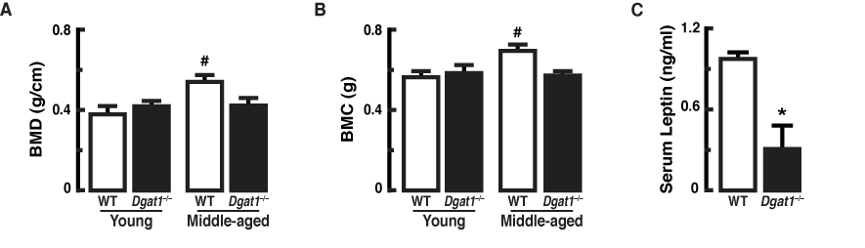
Supplemental Figure 1. Changes in bone mineral density, bone mineral content and leptin levels in middle-aged Dgat1–/– mice. (A) Bone mineral density and (B) bone mineral content are lower in middle-aged Dgat1^{−/−} versus WT mice. (C) Serum leptin levels are lower in middle-aged female mice [*p < 0.05 vs. wild-type (WT); n = 8–13]. “Young” and “Middle-aged” refer to ages 3–4 mo and 14–16 mo, respectively.

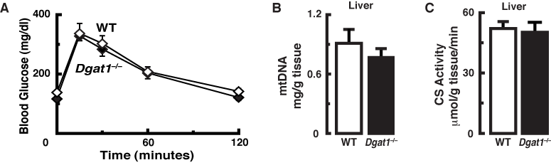

Supplemental Figure 2. Similar glucose tolerance and hepatic mitochondrial content in middle-aged WT and Dgat1–/– mice. (A) Blood glucose levels of middle-aged mice before and after an intraperitoneal injection of glucose (1 mg/g body weight). Mice were fed regular chow and fasted 5–6 hours before the test. (B) Mitochondrial (mt) DNA content and (C) citrate synthase (CS) activity, a marker of mitochondrial activity, from the livers of middle-aged mice (n=4 and 10, respectively).

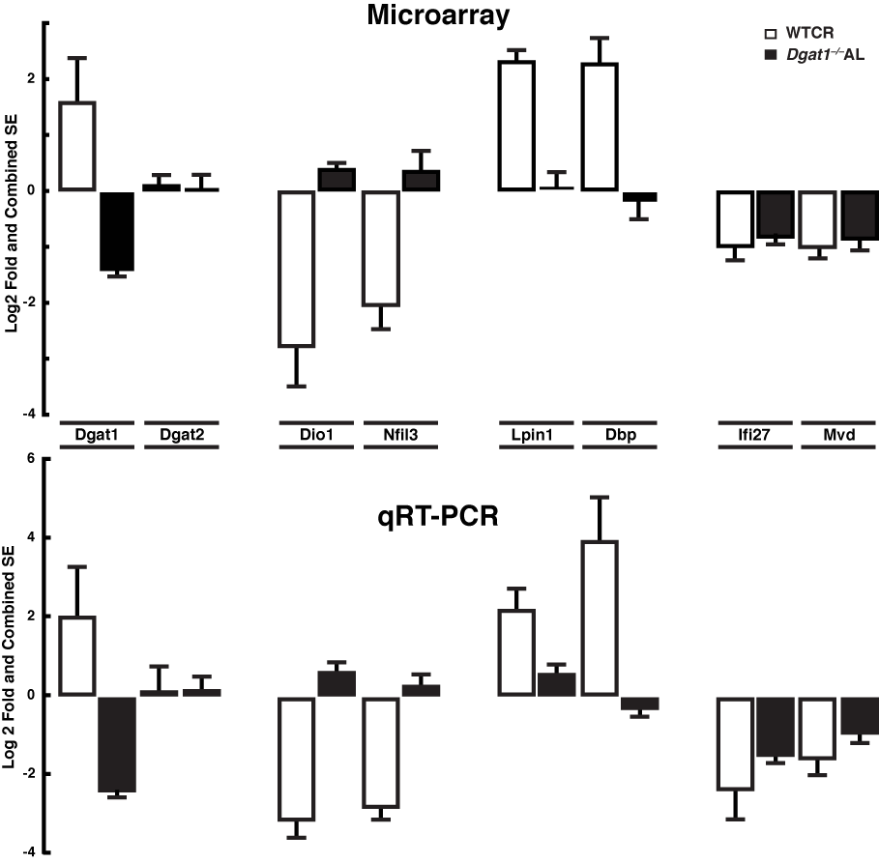

Supplemental Figure 3. Validation of microarray anlaysis with qRT-PCR. Differentially expressed genes in the livers of WTCR and Dgat1–/– AL vs. WT ad libitum mice. Values are mean ± SEM of biological triplicates.

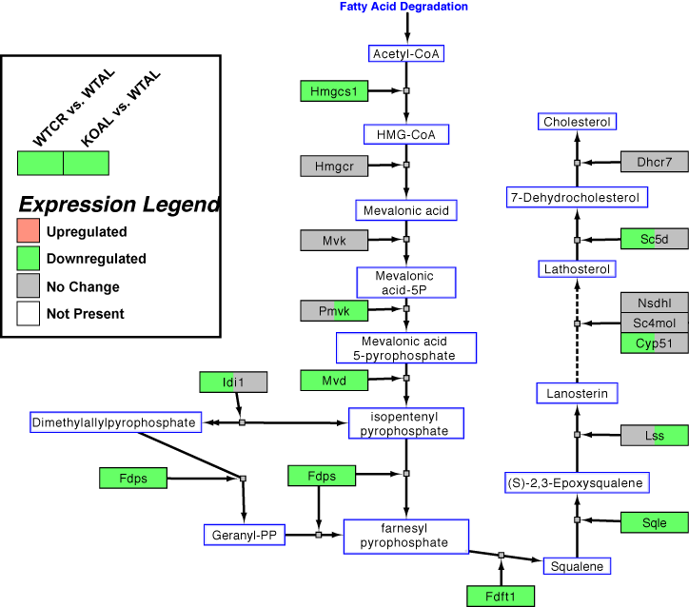

Supplemental Figure 4. Analysis of cholesterol biosynthesis pathway. Cholesterol biosynthesis pathway-highlighted genes (WikiPathways: WP103, revision 41337) that are significantly down-regulated in WTCR (left) or KOAL (right) relative to WTAL based on pathway analysis from the program GenMAPP-CS.

Supplemental Table 1.

A. Genes commonly up-regulated in liver of short-term calorie restricted wild-type (WTCR) and ad libitum Dgat1–/– (KOAL) middle-aged (15-16 mo) female mice.
ProbeSetID | GeneSymbol | fold.WTCR-WTAL | fold.KOAL-WTAL | rawP.WTCR-WTAL | rawP.KOAL-WTAL
10349431 | Acmsd | 1.51 | 2.15 | 2.4E-02 | 8.0E-04
10488608 | Trib3 | 1.83 | 1.78 | 4.8E-03 | 6.2E-03
10496077 | Agxt2l1 | 1.95 | 1.78 | 3.8E-04 | 1.0E-03
10593937 | Mpi | 1.52 | 1.47 | 9.5E-03 | 1.4E-02
10589099 | Ihpk2 | 1.72 | 1.44 | 8.8E-04 | 9.2E-03
10519607 | 4930420K17Rik | 1.42 | 1.43 | 2.2E-03 | 2.1E-03
10503023 | Cth | 1.31 | 1.43 | 9.8E-03 | 2.1E-03
10441359 | --- | 1.49 | 1.42 | 6.4E-03 | 1.3E-02
10368947 | Aim1 | 2.04 | 1.39 | 5.0E-05 | 7.6E-03
10571891 | Aadat | 1.69 | 1.39 | 3.3E-03 | 3.3E-02
10399430 | Ddx1 | 1.37 | 1.38 | 1.2E-02 | 1.2E-02
10464754 | Rhod | 1.96 | 1.37 | 7.6E-04 | 4.3E-02
10378568 | --- | 1.58 | 1.37 | 1.0E-03 | 9.4E-03
10434289 | --- | 1.55 | 1.36 | 1.2E-04 | 1.4E-03
10574641 | D230025D16Rik | 1.52 | 1.36 | 2.4E-03 | 1.4E-02
10585823 | LOC665268 | 1.36 | 1.35 | 3.0E-03 | 3.5E-03
10593671 | Dmxl2 | 1.75 | 1.34 | 7.0E-04 | 2.4E-02
10515187 | Cyp4a14 | 2.60 | 1.34 | 2.9E-05 | 4.0E-02
10409021 | Tpmt | 1.34 | 1.33 | 3.1E-03 | 3.4E-03
10357878 | Adora1 | 1.60 | 1.33 | 2.0E-03 | 2.9E-02
10354233 | Tgfbrap1 | 1.32 | 1.33 | 4.5E-02 | 4.1E-02
10581340 | Ranbp10 | 1.34 | 1.32 | 2.3E-02 | 3.0E-02
10398195 | Ccnk | 1.32 | 1.32 | 1.3E-02 | 1.3E-02
10593668 | Dmxl2 | 1.54 | 1.31 | 4.6E-03 | 4.0E-02
10410124 | Ctsl | 1.48 | 1.31 | 2.5E-03 | 1.7E-02
10475247 | Tmem62 | 1.35 | 1.31 | 2.7E-02 | 3.8E-02
10436200 | EG667802 | 1.44 | 1.31 | 1.3E-02 | 4.9E-02
10485622 | Qser1 | 1.34 | 1.31 | 6.3E-03 | 9.9E-03
10420216 | 2310014G06Rik | 1.60 | 1.31 | 1.3E-04 | 5.0E-03

B. Genes commonly down-regulated in liver of short-term calorie restricted wild-type (WTCR) and ad libitum Dgat1-/- (KOAL) middle-aged (15-16 mo) female mice.
ProbeSetID | GeneSymbol | fold.WTCR-WTAL | fold.KOAL-WTAL | rawP.WTCR-WTAL | rawP.KOAL-WTAL
10531126 | Igj | -5.01 | -2.86 | 1.1E-03 | 1.3E-02
10523359 | Cxcl13 | -2.80 | -2.52 | 2.6E-02 | 4.1E-02
10585699 | ENSMUST00000098689 | -3.58 | -2.26 | 1.9E-04 | 3.7E-03
10509163 | Id3 | -2.29 | -2.19 | 8.3E-04 | 1.2E-03
10490838 | Fabp5 | -3.41 | -2.14 | 4.2E-04 | 8.0E-03
10425161 | Lgals1 | -1.62 | -2.00 | 4.5E-02 | 8.9E-03
10361246 | G0s2 | -2.51 | -1.95 | 1.6E-04 | 1.4E-03
10425822 | Pnpla3 | -1.99 | -1.94 | 3.2E-02 | 3.8E-02
10603860 | Cfp | -1.50 | -1.87 | 4.3E-02 | 5.5E-03
10587082 | Onecut1 | -1.69 | -1.82 | 1.5E-03 | 6.1E-04
10446282 | Emr1 | -2.19 | -1.80 | 2.7E-03 | 1.3E-02
10365830 | --- | -1.53 | -1.77 | 2.2E-02 | 5.0E-03
10582310 | Mvd | -1.95 | -1.77 | 5.3E-04 | 1.5E-03
10402347 | Ifi27 | -1.94 | -1.73 | 2.9E-04 | 1.1E-03
10407281 | Esm1 | -1.53 | -1.72 | 1.7E-03 | 3.3E-04
10571321 | Ppp1r3b | -1.43 | -1.69 | 2.3E-02 | 3.1E-03
10385504 | EG432555 | -1.91 | -1.69 | 2.5E-04 | 1.0E-03
10438405 | Igl-V1 /// Igl-J2 /// Igl-V2 /// LOC433053 | -1.88 | -1.66 | 9.3E-04 | 3.5E-03
10501063 | Cd53 | -1.59 | -1.64 | 1.0E-02 | 7.5E-03
10517165 | Cd52 | -2.16 | -1.63 | 1.2E-05 | 3.4E-04
10455015 | --- | -3.90 | -1.63 | 1.1E-04 | 4.2E-02
10404606 | Ly86 | -1.85 | -1.61 | 2.9E-03 | 1.2E-02
10461614 | Ms4a6c | -2.76 | -1.61 | 2.8E-05 | 5.0E-03
10385518 | Tgtp /// OTTMUSG00000005523 | -3.25 | -1.61 | 6.6E-05 | 1.9E-02
10458890 | --- | -1.41 | -1.59 | 4.1E-03 | 6.2E-04
10545187 | EG628498 /// Gm1502 /// Igkv4-74 /// Gm1524 /// LOC100047316 | -1.93 | -1.59 | 6.9E-04 | 5.8E-03
10538903 | ENSMUSG00000076577 /// Igk-V28 /// Igkv6-25 /// Igk-V21-4 /// Igk /// Gm1499 /// LOC676193 | -2.10 | -1.59 | 4.7E-04 | 8.5E-03
10466200 | Ms4a7 | -1.69 | -1.58 | 7.9E-03 | 1.6E-02
10499483 | Fdps | -1.39 | -1.58 | 3.0E-02 | 6.1E-03
10403034 | Igh /// LOC676399 /// LOC100046275 | -1.74 | -1.57 | 1.4E-02 | 3.5E-02
10385533 | Tgtp /// OTTMUSG00000005523 | -2.81 | -1.56 | 3.2E-04 | 3.5E-02
10603551 | Cybb | -1.82 | -1.56 | 2.9E-03 | 1.4E-02
10444258 | Psmb8 | -2.08 | -1.56 | 1.1E-04 | 3.1E-03
10403063 | Igh /// LOC100046275 /// LOC676399 | -1.57 | -1.54 | 1.1E-02 | 1.4E-02
10368240 | Tcf21 | -1.40 | -1.53 | 1.3E-02 | 3.7E-03
10517517 | C1qa | -1.45 | -1.53 | 1.9E-02 | 9.6E-03
10545237 | --- | -1.37 | -1.53 | 6.3E-03 | 1.1E-03
10403743 | Inhba | -1.42 | -1.52 | 2.2E-03 | 7.1E-04
10531724 | Plac8 | -2.20 | -1.52 | 1.6E-03 | 4.0E-02
10444291 | H2-Ab1 /// Rmcs5 /// Rmcs2 | -3.02 | -1.52 | 8.5E-06 | 6.9E-03
10450154 | H2-Aa | -3.57 | -1.52 | 2.1E-05 | 2.4E-02
10545198 | EG667683 /// Igk /// Gm1499 /// Gm1524 | -1.79 | -1.51 | 2.3E-03 | 1.5E-02
10545184 | EG628498 /// Igkv4-74 /// Gm189 /// Gm1524 /// LOC100047316 | -2.02 | -1.51 | 2.7E-04 | 7.8E-03
10503359 | C430048L16Rik | -1.67 | -1.50 | 4.4E-04 | 2.2E-03
10412466 | Hmgcs1 | -2.41 | -1.49 | 1.6E-04 | 1.8E-02
10496592 | Gbp2 | -2.00 | -1.49 | 2.1E-03 | 3.5E-02
10545196 | Igk-C /// Gm1524 /// Igk /// Gm1499 /// Gm1418 /// Gm189 /// Igkv4-74 | -1.57 | -1.49 | 1.5E-04 | 3.7E-04
10379630 | Slfn2 | -1.89 | -1.49 | 7.0E-05 | 1.8E-03
10556018 | --- | -1.49 | -1.48 | 1.8E-02 | 1.9E-02
10576774 | Clec4g | -2.00 | -1.48 | 1.7E-05 | 1.1E-03
10389231 | Ccl3 | -1.38 | -1.47 | 1.5E-02 | 6.0E-03
10539433 | Mobkl1b | -1.59 | -1.47 | 1.3E-02 | 3.1E-02
10559467 | Pira11 /// Pira6 /// Pira4 /// Pira3 /// Pira7 /// OTTMUSG00000022068 /// Pira2 /// Lilrb3 | -1.66 | -1.45 | 3.4E-04 | 2.5E-03
10582303 | Cyba | -1.46 | -1.45 | 1.0E-02 | 1.0E-02
10389207 | Ccl5 | -1.89 | -1.45 | 1.7E-03 | 2.9E-02
10466606 | Anxa1 | -1.35 | -1.45 | 3.3E-02 | 1.3E-02
10424349 | Sqle | -1.35 | -1.44 | 2.0E-02 | 8.3E-03
10568024 | Coro1a | -1.62 | -1.41 | 6.2E-04 | 4.7E-03
10401181 | Rdh11 | -1.69 | -1.41 | 2.0E-03 | 1.9E-02
10607865 | Tmsb4x | -2.23 | -1.41 | 2.4E-05 | 7.2E-03
10545731 | Clec4f | -1.69 | -1.41 | 5.6E-04 | 7.3E-03
10569646 | Ccnd1 | -4.08 | -1.41 | 2.0E-06 | 2.4E-02
10421648 | Slc25a30 | -2.16 | -1.40 | 1.8E-04 | 2.5E-02
10545202 | Gm1077 /// Gm1418 | -1.39 | -1.39 | 1.6E-02 | 1.6E-02
10555087 | --- | -1.37 | -1.39 | 1.3E-02 | 1.0E-02
10420730 | Fdft1 | -1.32 | -1.39 | 2.9E-02 | 1.3E-02
10360382 | Ifi204 /// Mnda /// Ifi205 | -2.45 | -1.38 | 1.1E-04 | 4.3E-02
10503995 | Dnaja1 | -1.81 | -1.38 | 1.8E-03 | 4.3E-02
10358224 | Ptprc | -2.43 | -1.37 | 5.8E-05 | 3.0E-02
10444298 | H2-Eb1 | -2.43 | -1.36 | 1.1E-04 | 4.7E-02
10539135 | Capg | -1.35 | -1.35 | 6.2E-03 | 5.9E-03
10367050 | Rdh18 | -1.31 | -1.35 | 3.3E-02 | 2.1E-02
10473125 | Itga4 /// Cerkl | -1.52 | -1.35 | 8.7E-04 | 6.5E-03
10480699 | Dpp7 | -1.65 | -1.35 | 2.0E-04 | 5.3E-03
10569102 | Irf7 | -1.56 | -1.35 | 6.6E-03 | 4.0E-02
10548892 | Arhgdib | -1.53 | -1.35 | 7.7E-04 | 6.8E-03
10356020 | Dock10 | -1.94 | -1.34 | 6.3E-07 | 3.2E-04
10531952 | Abcg3 | -1.87 | -1.34 | 5.4E-04 | 3.4E-02
10412207 | 2310016C16Rik | -1.44 | -1.34 | 7.4E-03 | 2.1E-02
10366640 | 1190005P17Rik | -1.35 | -1.34 | 8.2E-03 | 9.0E-03
10385513 | EG432555 /// 9930111J21Rik /// Psme2b-ps /// RP23-269N23.3 | -1.91 | -1.34 | 4.0E-05 | 8.0E-03
10367066 | Rdh20 | -3.46 | -1.32 | 1.7E-06 | 3.2E-02
10563441 | Emp3 | -1.41 | -1.32 | 4.5E-03 | 1.4E-02
10524621 | Oasl2 | -1.55 | -1.32 | 7.4E-04 | 1.1E-02
10603573 | Sytl5 | -1.91 | -1.32 | 1.8E-05 | 6.2E-03
10395612 | 6030408C04Rik | -1.35 | -1.31 | 1.4E-02 | 2.2E-02
10466210 | Ms4a6d | -1.37 | -1.31 | 2.8E-03 | 6.9E-03
10500335 | Fcgr1 | -1.43 | -1.31 | 9.0E-03 | 3.4E-02
10403079 | LOC435333 | -1.51 | -1.30 | 5.2E-04 | 7.9E-03
10530910 | Uba6 | -1.77 | -1.30 | 6.3E-04 | 4.1E-02

Supplementary Table 2. Primers used for quantitative RT-PCR analysis.

Gene | Sequence
Dgat1 | F: 5'- GACGGCTACTGGGATCTGA -3'  R: 5'- TCACCACACACCAATTCAGG -3'
Dgat2 | F: 5'- CGCAGCGAAAACAAGAATAA -3'  R: 5'- GAAGATGTCTTGGAGGGCTG -3'
Dio1 | F: 5'- ccctggtgttgaactttggc -3'  R: 5'- tgaggaaatcggctgtgga -3'
Nfil3 | F: 5'- CTTTCTTTTCCCCCTCACG -3'  R: 5'- CATCCATCAATGGGTCCTTC -3'
Lpin1 | F: 5'- TTTTTGCATACAAAGGCAGC -3'  R: 5'- TTCACCGTCACAAACACCTG -3'
Dpb | F: 5'- cgcgcaggcttgacatcta -3'  R: 5'- tgaggaaatcggctgtgga-3'
Ifi27 | F: 5'- GTTGGGAACACTGTTTGGCT -3'  R: 5'- CAATGCCTGTCCCAGTGAA -3'
Mvd | F: 5'- CGGTCAACATCGCAGTTATC - 3'  R: 5'- TCGTTTTTAGCTGGTCCTGG -3'

