Supplementary Material II. Identification of Cysltr1-/- mice.

Identifications for Cysltr1^{-/-} mice
Notes
Cysltr1 with X-chromosomal inheritance Wt=253bp -50bp=203bp
Primers
for Cysltr1 identification
2322-Cysltr1-F1-tF1 GAATGGAACTGAAAATCTGACGAC
2322-Cysltr1-F1-tR1 ATAATAGACCACACGGAGAGGCA
PCR reaction system
Reaction Components | Volume (μL)
gDNA template | 2.0
10×Taq buffer (mg²⁺ plus) | 2.0
dNTP mixture (10 mM) | 0.5
Primer mixture (10 μM) | 0.5
Taq DNA polymerase (5 U/µL) | 0.5
Milli-Q H₂O | To 20μL
PCR programs
Temperature | Time | Cycle
95ºC | 5 min
95 ºC | 30 s | 20
65ºC | 30 s | 20
72 ºC | 30 s | 20
95 ºC | 30 s | 20
55 ºC | 30 s | 20
72 ºC | 30 s | 20
72 ºC | 3 min
25 ºC | hold

Gel concentration
3.0%
Electrophoretic pattern 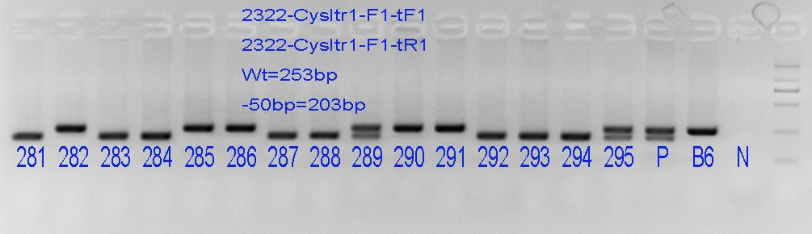
Result adjudication
-50bp/-50bp or -50bp/Y: 281, 283, 284, 287, 288, 292-294
-50bp/wt: 289, 295
Wt/Y: the rest (for male)

