Supplementary Material III. Identification of APP/PS1 Cysltr1-/- mice.

Identifications for APP/PS1 Cysltr1^{-/-} mice
Primers
for Cysltr1 identification
Wt=253bp -50bp=203bp
2322-Cysltr1-F1-tF1 GAATGGAACTGAAAATCTGACGAC
2322-Cysltr1-F1-tR1 ATAATAGACCACACGGAGAGGCA

for APP identification
TG=350bp WT=None
oIMR1597 GACTGACCACTCGACCAGGTTCTG
oIMR1598 CTTGTAAGTTGGATTCTCATATCCG

for PSEN1 identification
TG=608bp WT=None
oIMR1644 AATAGAGAACGGCAGGAGCA
oIMR1645 GCCATGAGGGCACTAATCAT
PCR reaction system
Reaction Components | Volume （μL）
gDNA template | 2.0
10×Taq buffer (mg²⁺ plus) | 2.0
dNTP mixture (10 mM) | 0.5
Primer mixture (10 μM) | 0.5
Taq DNA polymerase (5 U/µL) | 0.5
Milli-Q H₂O | To 20μL
PCR programs
P1
Temperature | Time | Cycle
95ºC | 5 min
95 ºC | 30 s | 20
65ºC | 30 s | 20
72 ºC | 30 s | 20
95 ºC | 30 s | 20
55 ºC | 30 s | 20
72 ºC | 30 s | 20
72 ºC | 3 min
25 ºC | hold

P2, P3
Temperature |  | Time |  | Cycle
95ºC | 5 min
95 ºC | 30 s |  | 40
60ºC | 30 s
72 ºC | 30 s
72 ºC | 3 min
25 ºC | hold

Gel concentration
3.0% for P1, 1.5% for P2 and P3

Electrophoretic pattern
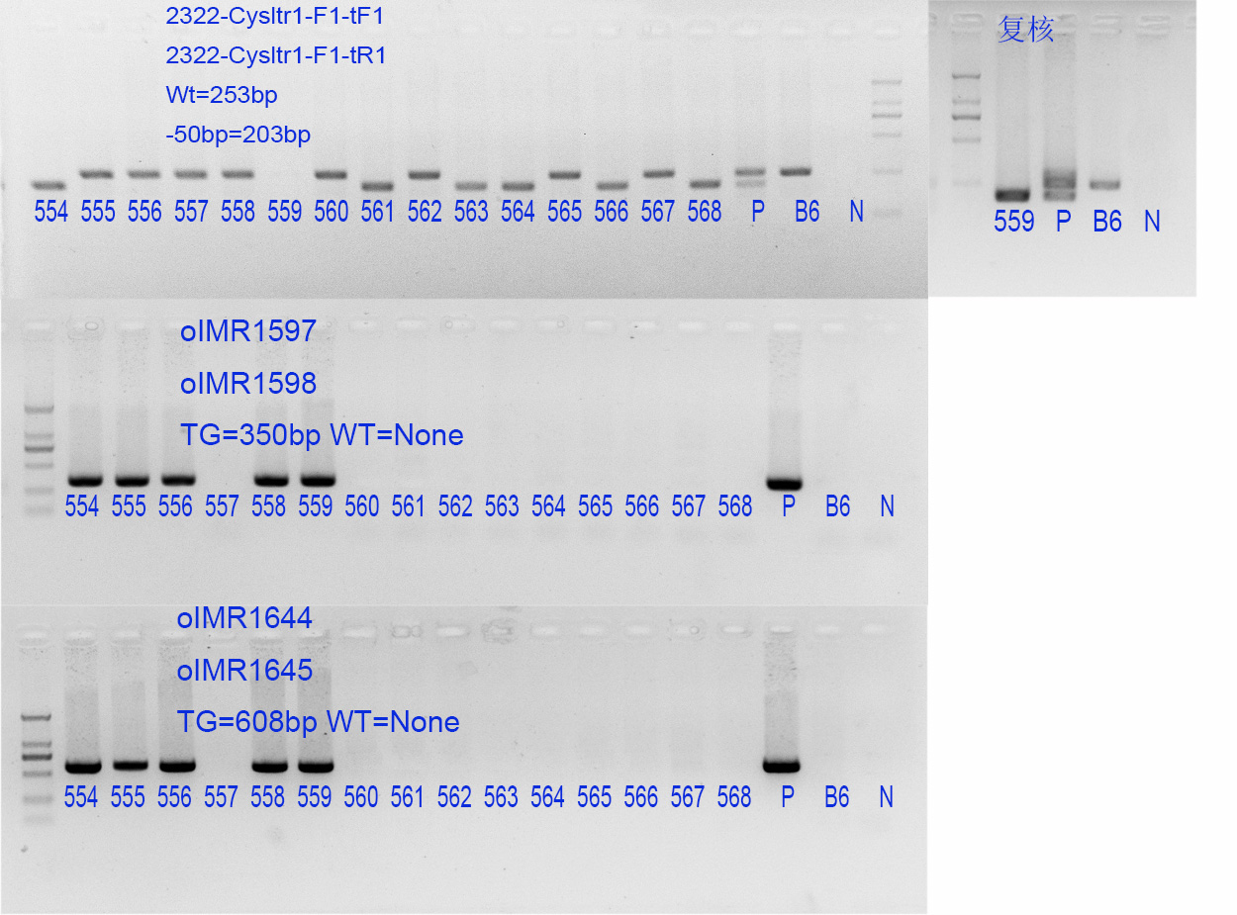
Result adjudication
identification for Cysltr1
-50bp/-50bp or-50bp/Y: 554, 559, 561, 563, 564, 566, 568
WT/WT or WT/Y: the rest (for male)

identification for APP and PSEN1
TG: 554-556, 558, 559
WT: the rest

